* When we talk about mobile apps in cloud it usually it means the Backend of your application running on mobile.
* Notifications Hubs: [https://docs.microsoft.com/en-us/azure/notification-hubs/notification-hubs-push-notification-overview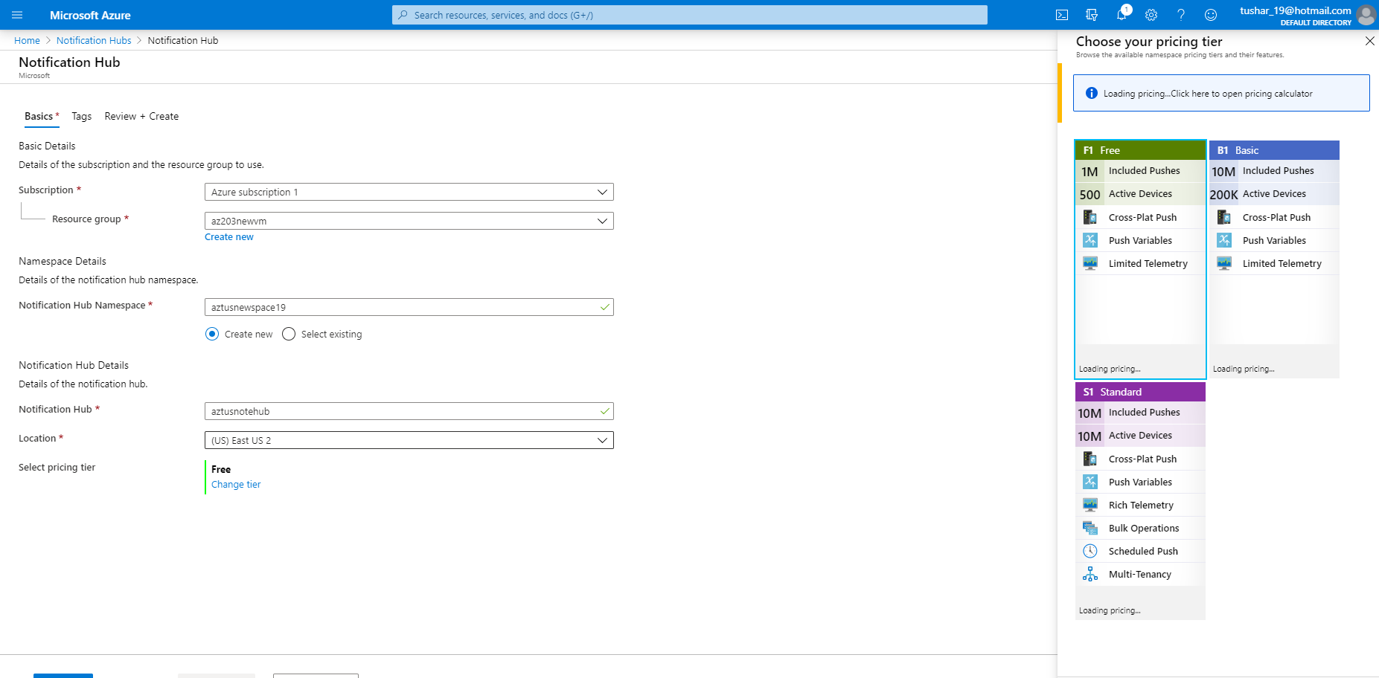](https://docs.microsoft.com/en-us/azure/notification-hubs/notification-hubs-push-notification-overview#)
* You can connect these apps with this hub, as this is basically supporting the backend of the mobile apps.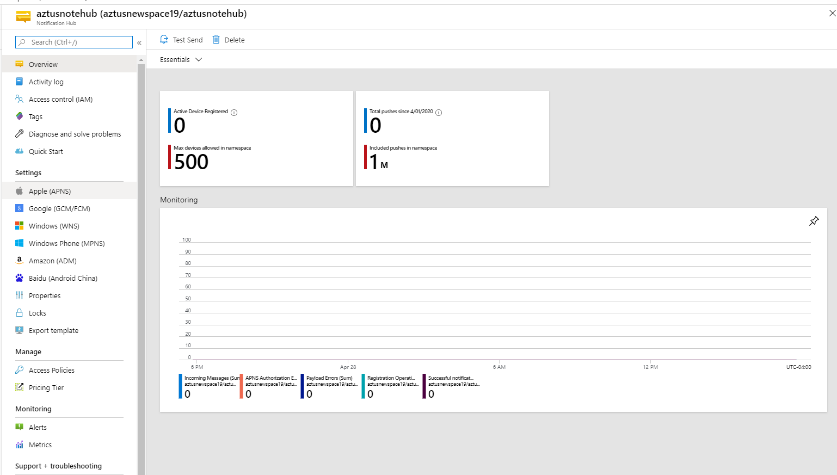
* Now Create a mobile app with the same steps as Web app. 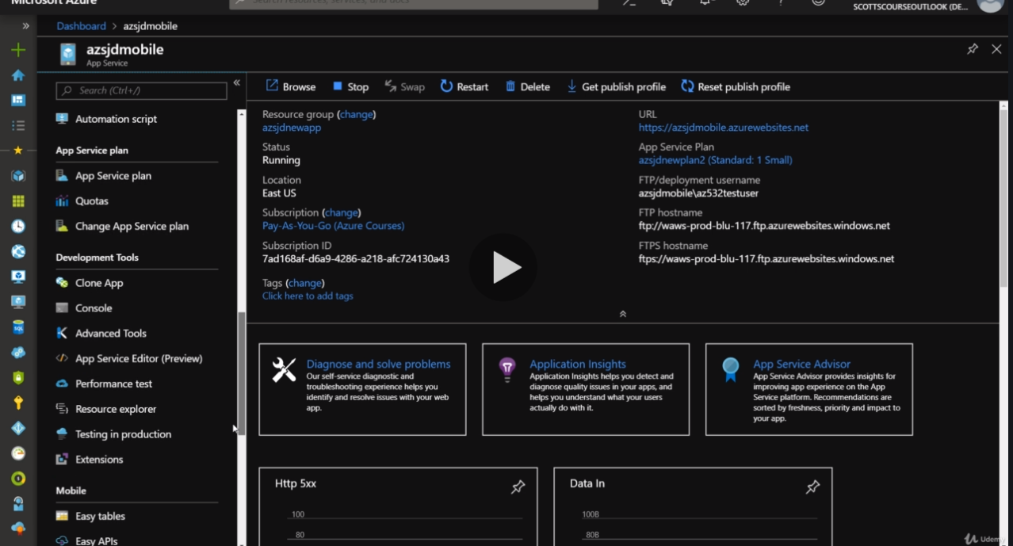
* Action will happen in mobile section od settings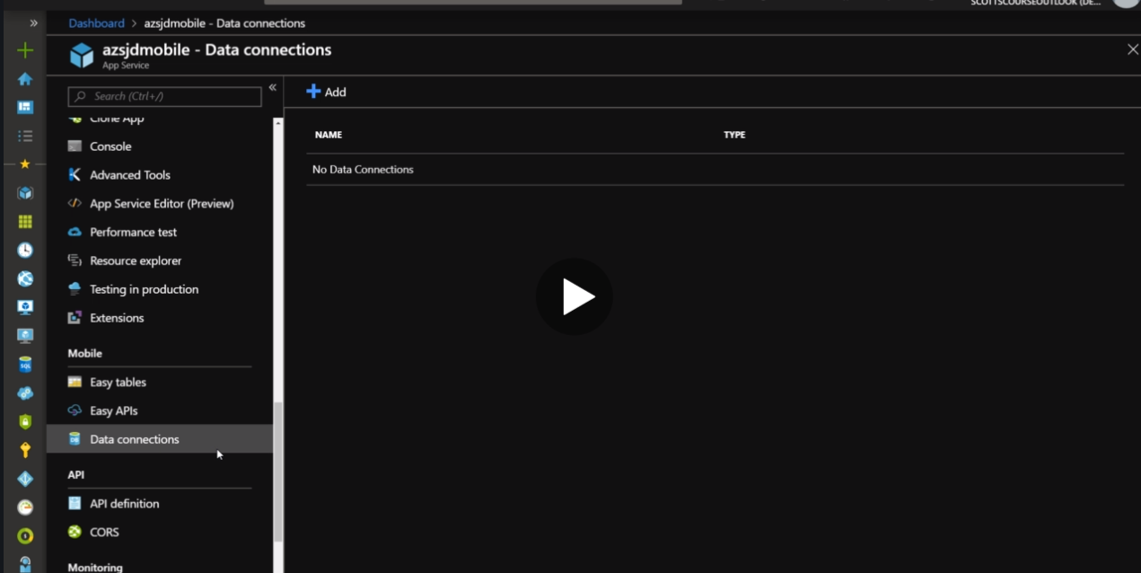
* Data Connection will require you to store stuff in SQL Databases or Storage accounts. <https://docs.microsoft.com/en-us/previous-versions/azure/app-service-mobile/app-service-mobile-android-get-started>